P2 Processing and Visualising Data

# Repository link:

<https://github.com/alisonvpereira/P2_Processing_and_Visualising_Data.git>

# Part 1: Forecast Summary

## Test output

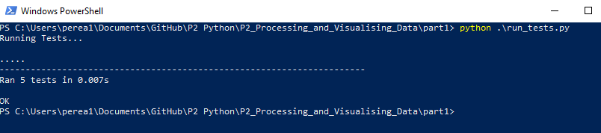

Part 2: Forecast Graphs

### Time series graph that contains both the minimum and maximum temperatures for each day

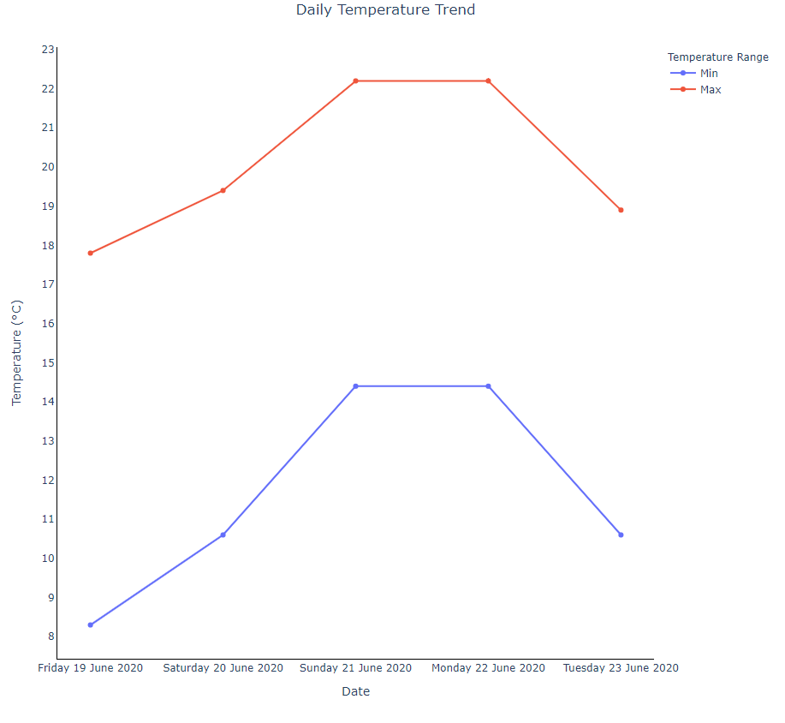

### Time series graph that contains the minimum, minimum “real feel”, and minimum “real feel shade” temperatures.

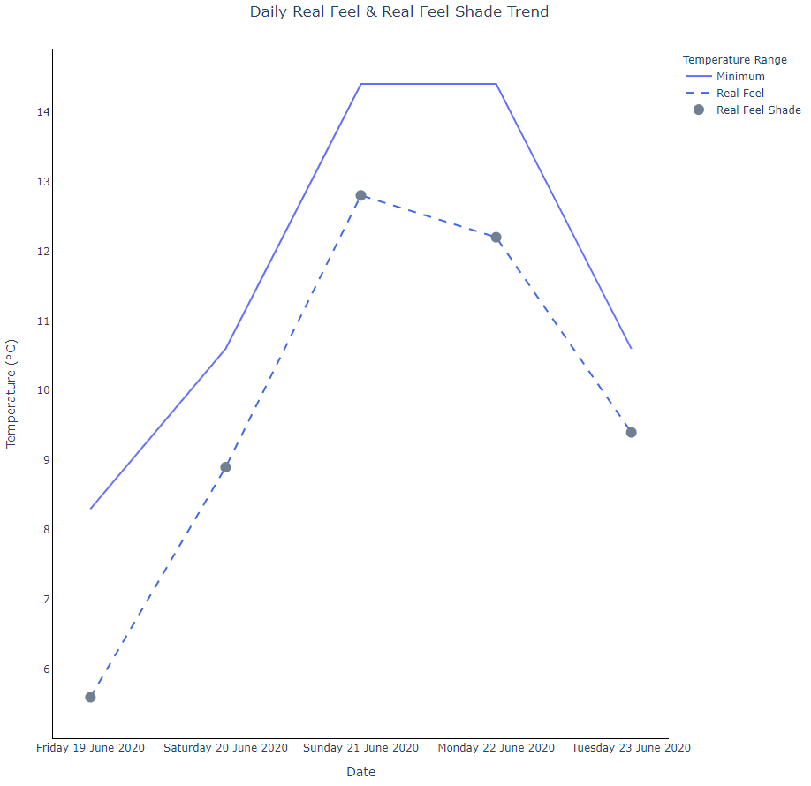

# Part 3: Historical Data Graphs and Summary

Single graph that contains two box plots, one for the temperature and one for the real feel temperature.

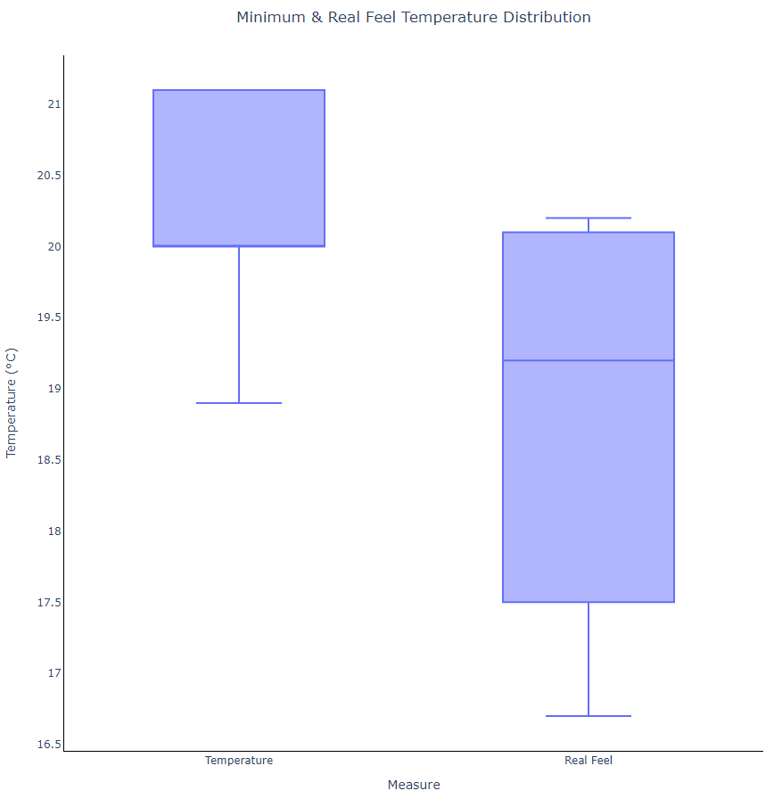

### Bar graph showing the number of times each “WeatherText” category occurs

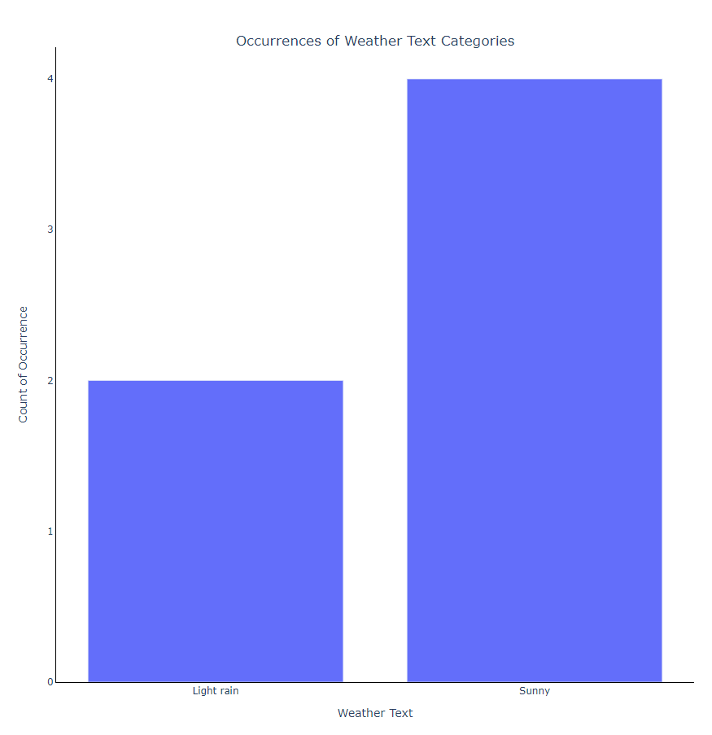

### Text file output:

